2.46: a) The vertical distance from the initial position is given by

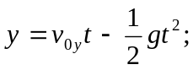

solving for v_{0y},

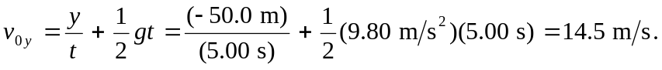

b) The above result could be used in 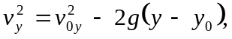 with v = 0, to solve for y – y₀ = 10.7 m (this requires retention of two extra significant figures in the calculation for v_{0y}). c) 0 d) 9.8 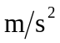, down.

e) Assume the top of the building is 50 m above the ground for purposes of graphing:

